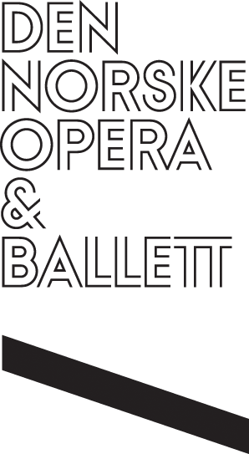

PRESS RELEASE FROM

DEN NORSKE OPERA & BALLETT

Thursday 16 October 2025

**Norwegian National Opera Receives *Gramophone*’s 2025 Opera Award**

**Major International Accolade Celebrates the Company’s Outstanding Artistic Achievement**

The Norwegian National Opera & Ballet’s recording of Richard Wagner’s *Der fliegende Höllander* has won the2025 Opera Award from *Gramophone*, the world’s leading magazine for classical record reviews. The coveted accolade, chosen from a formidable shortlist of six nominees, was awarded to the Company by an expert panel of *Gramophone* critics.

Bass-baritone Gerald Finley, who sang the title role in the recording, was on stage at the De Vere Connaught Rooms in central London yesterday evening to receive the award during the prestigious *Gramophone* Classical Awards ceremony. Opera Director Randi Stene was also present at the event, while the Norwegian National Opera’s Music Director Edward Gardner and soprano Lise Davidsen sent their thanks via a pre-recorded video message.

*Der fliegende Höllander* was recorded live by Decca Classics during a run of four concert performances given in the summer of 2024 on the Main Stage at the Oslo Opera House. The album received universal critical acclaim following its release last April. *Gramophone* praised the profound psychological, musical and dramatic insights revealed by a compelling cast, led by Gerald Finley as The Dutchman and Lise Davidsen as Senta, and underlined the recording’s status as ‘an alert, cohesive, significant addition to the discography’.

*Gramophone*’s Opera Award was won jointly by the Norwegian National Opera, its Opera Orchestra, Opera Chorus and superlative soloists under the direction of the Company’s Music Director Edward Gardner. In addition to Finley and Davidsen, the album’s star-studded company of singers includes Brindley Sherratt (Daland), Stanislas de Barbeyrac (Erik), Eirik Grøtvedt (Steersman), and Anna Kissjudit (Mary).

**All-embracing recognition for Norwegian National Opera**

“*Gramophone*’s Award for *Der fliegende Höllander* is a major recognition for the entire National Opera – for the Opera Chorus, the Opera Orchestra, and the soloists on stage,” says Opera Director Randi Stene. “Decca’s recording captures a historic moment with what will most likely be Lise Davidsen’s only interpretation of Senta. Together with our musicians under Edward Gardner, who has elevated the Norwegian National Opera Orchestra to a high international level, this has become a recording that truly puts the Oslo Opera House on the world map.”

The *Gramophone* Awards, established in 1977, are considered to be among the most esteemed and significant honours in the field of classical music. This is the fourth time Edward Gardner has received the *Gramophone* Award in the opera category. His recording of Benjamin Britten’s *Peter Grimes* with the Bergen Philharmonic Orchestra also gained the cherished Recording of the Year Award in 2021.

“This Award for *Der fliegende Höllander* is about how the music came alive on stage in those evenings,” says Edward Gardner. “I experienced our orchestra’s incredible vitality, a chorus that gave everything, and soloists who threw themselves into the drama with full force. Capturing this in such a vivid recording feels truly special. I’m proud of what we’ve achieved together.”

Gardner is currently Music Director of both the Norwegian National Opera & Ballet and the London Philharmonic Orchestra, as well as Honorary Conductor of the Bergen Philharmonic Orchestra.

**More Wagner to come at Norwegian National Opera**

The Norwegian National Opera will soon embark on one of the most ambitious and demanding projects an opera house can undertake: a new production of Richard Wagner’s *Der Ring des Nibelungen*. The tetralogy, which spans more than 15 hours of music, will be staged by director Tatjana Gürbaca between 2027 and 2030. With the Opera Orchestra as his constant companion throughout *The Ring*, Edward Gardner will lead the production from the pit. Their collaboration with Gürbaca in Dvořák’s *Rusalka* this autumn received high critical praise, boding well for Norwegian National Opera’s inaugural *Ring* cycle.

For images from the Gramophone Awards’ ceremony, please click [here.](https://www.dropbox.com/scl/fo/k26dk5f3c987puy57sjdq/AOlBJ1KIoYrjEk67cBS4NAo?rlkey=djphum7fh445cqj5ckuz0hwp9&st=8xdk11fa&dl=0)

**For press enquiries, please contact:**

Ole-Morten Vestby, Head of Public Relations, The Norwegian Opera & Ballet

omv@operaen.no / www.operaen.no

Valerie Barber at Valerie Barber PR

valerie@vbpr.co.uk / +44 (0)20 7586 8560 / www.vbpr.co.uk